COMP 1630

Relational Database & SQL

Project 1

Gaël Attal

Renin Joseff Catungal

Wing Chu

Xiaochen (Alex) Dai

Contents

Introduction 3

Business Rules 4

Normalized Relational Schemas 5

First Normal Form 5

Second Normal Form 5

Third Normal Form 5

Normalized Relational Schema WIth Bridge Entities 5

Entity Relationship Diagrams 6

Draft ERD 6

Final ERD 6

Sample Data 7

ALUMNI ENTITY 7

ACT_MSHIP ENTITY 8

APPLICATION ENTITY 9

CLUB ENTITY 10

DONATION ENTITY 11

EVENT ENTITY 12

FMR_MSHIP ENTITY 13

INTEREST ENTITY 14

INVITATION ENTITY 15

Sample Reports 16

Report 1: Membership Tracker 16

Report 2: Member's Events 17

Report 3: Club Member's Information 18

Report 4: Alumni's Donations 19

Process Descriptions 20

Assumptions/LImitations 21

Conclusions - Observations 22

# Introduction

We see before us a college alumni system which describes the processes relating alumni students to various Interest and Activity clubs. This relationship between students and clubs manifests itself in a number of different ways, from being able to donate to your favorite clubs (or just make general donations), to being part of an active club membership and being invited to a number of club-hosted events.

The implementation of such a system obviously requires some database design in order to function. While the scope of this design does not exceed the information given (which itself only pertains to particular aspects of the Alumni-Club relationship), what we've chosen to implement can easily be expanded as more information becomes readily available and as the relationships described become more specific/tailored to particular needs.

The breakdown of our database design in this presentation is as follows:

**Business Rules:** A list of our formal business rules describing the nature of our relationships between the entities that we've chosen.

**Normalized Relational Schemas:** The final list of entities and their corresponding attributes which we've come to after Normalizing to 3NF and then implementing the bridge entities to resolve M:N relationships described in our Business Rules.

**Entity Relationship Diagrams:** A draft ERD and a final ERD which implements our Business Rules and final Relational Schemas describing the relationships between entities and resolving M:N relationships.

**Sample Data:** Examples of sample tables containing data that corresponds to the entities and attributes we've created, for demonstration purposes.

**Sample Reports:** Examples of reports we are able to generate given the final implementation of our database.

**Process Descriptions:** The series of methods we've utilized to arrive at our final solution.

**Assumptions/Limitations:** A list of assumptions that we've made while constructing our Business Rules, Relational Schemas, and final ERD. The database cannot operate (or does not make sense) without granting certain assumptions from the get-go. Also a list of limitations describing both the scope of our database and limitations it encounters when trying to answer certain questions or generate certain reports.

**Conclusions/Observations:** Some final thoughts on the project, including problems we've encountered.

# Business Rules

These are the Business Rules for the database design we have chosen. They operate under several assumptions which can be found under the Assumptions/Limitations section of this presentation.

* Each alumni may donate to many clubs.
* Each club may receive donations from many alumni.
* Each alumni must belong to least one club.
* Each club may have many alumni.
* Each alumni must generate at least one application.
* Each application is generated by only one alumni.
* Each interest may result in many applications.
* Each application must be the result of only one interest.
* Each invitation may come from many interests.
* Each interest may be considered in an invitation.
* Each alumni may be invited to many events.
* Each event may invite many alumni.
* Each club may host many events.
* Each event must be hosted by only one club.
* Each club may contain many active memberships.
* Each active membership must correlate to only one club.
* Each application may result in many active memberships.
* Each active membership must be the result of only one application.
* Each active membership may become a former membership.
* Each former membership must have been an active membership

# Normalized Relational Schemas

### First Normal Form

ALUMNI ( **AL_ID, CLUB_ID, EVENT_ID,** AL_FNAME, AL_LNAME, AL_EMAIL, AL_COUNTRY, AL_CITY, AL_STREET, AL_RES_NUM, AL_POSTCODE, AL_PHONE, GRAD_SUBJ, GRAD_YEAR, INTEREST_NAME, DONATION_AMT, DONATION_REGULARITY, DONATION_DATE, DONATION_METHOD, INVITATION_TYPE, EVENT_TYPE, EVENT_TITLE, EVENT_DATE, EVENT_FEE, EVENT_LOCATION, MSHIP_SDATE, MSHIP_EDATE, LAST_PAYMENT_DATE, CLUB_NAME, CLUB_FEE )

### Second Normal Form

ALUMNI ( **AL_ID**, AL_FNAME, AL_LNAME, AL_EMAIL, AL_COUNTRY, AL_CITY, AL_STREET, AL_RES_NUM, AL_POSTCODE, AL_PHONE, GRAD_SUBJ, GRAD_YEAR, DONATION_AMT, DONATION_REGULARITY, DONATION_DATE, DONATION_METHOD )

CLUB ( **CLUB_ID**, CLUB_NAME, CLUB_FEE )

EVENT ( **EVENT_ID**, EVENT_TYPE, EVENT_TITLE, EVENT_DATE, EVENT_FEE, EVENT_LOCATION )

INVITATION ( **AL_ID(FK), EVENT_ID(FK)**, INVITATION_TYPE )

MEMBERSHIP ( **AL_ID(FK), CLUB_ID(FK), MSHIP_SDATE**, MSHIP_EDATE, LAST_PAYMENT_DATE )

INTEREST ( **INTEREST_ID,** INTEREST_NAME )

### Third Normal Form

ALUMNI (**AL_ID**, AL_FNAME, AL_LNAME, AL_EMAIL, AL_COUNTRY, AL_CITY, AL_STREET, AL_RES_NUM, AL_POSTCODE, AL_PHONE, GRAD_SUBJ, GRAD_YEAR )

CLUB ( **CLUB_ID**, CLUB_NAME, CLUB_FEE )

DONATION ( **DONOR_ID(FK)**, DON_AMT, DON_REGULARITY, DON_DATE, DON_METHOD )

EVENT ( **EVENT_ID**, EVENT_TYPE, EVENT_TITLE, EVENT_DATE, EVENT_FEE, EVENT_LOCATION )  
INVITATION ( **AL_ID(FK), EVENT_ID(FK)**, INVITATION_TYPE )

MEMBERSHIP (**AL_ID(FK), CLUB_ID(FK)**, MSHIP_SDATE, MSHIP_EDATE, LAST_PAYMENT_DATE )

INTEREST ( **INTEREST_ID**, INTEREST_NAME )

### Normalized Relational Schema WIth Bridge Entities

ALUMNI ( **AL_ID**, AL_FNAME, AL_LNAME, AL_EMAIL, AL_COUNTRY, AL_CITY, AL_STREET, AL_RES_NUM, AL_POSTCODE, AL_PHONE, GRAD_SUBJ, GRAD_YEAR )

CLUB ( **CLUB_ID**, CLUB_NAME, CLUB_FEE )

APPLICATION ( **APP_NUM**, ALUMNI_ID (FK), APP_DATE )

INTEREST ( **INTEREST_ID**, APP_NUM (FK), INTEREST_NAME )

DONATION ( **DON_ID (FK), CLUB_ID (FK)**, DON_AMT, DON_REGULARITY, DON_DATE, DON_METHOD )

INVITATION ( **ALI_ID (FK), EVENT_ID (FK)**, INTEREST_ID (FK), INV_TYPE)

EVENT ( **EVENT_ID**, CLUB_ID (FK), EVENT_TYPE, EVENT_TITLE, EVENT_DATE, EVENT_FEE, EVENT_LOCATION )

ACT_MSHIP ( **APP_NUM (FK)**, CLUB_ID (FK), SDATE, LAST_PAYMENT_DATE )

FMR _MSHIP ( **APP_NUM (FK)**, SDATE (FK), CLUB_ID (FK), EDATE )

# Entity Relationship Diagrams

### Draft ERD

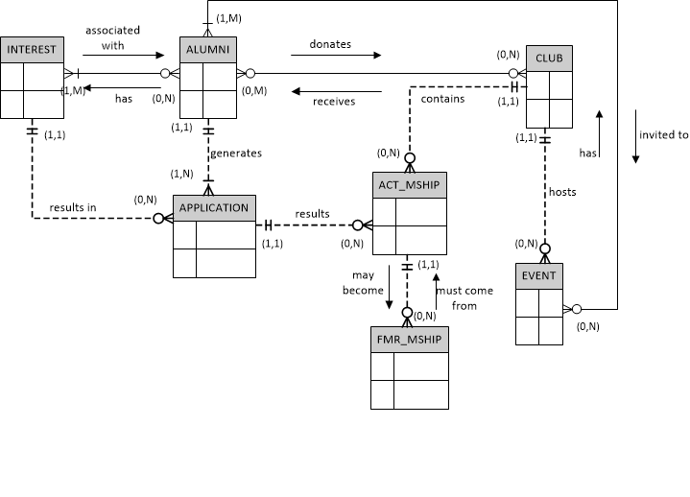

### Final ERD

# Sample Data

### ALUMNI ENTITY

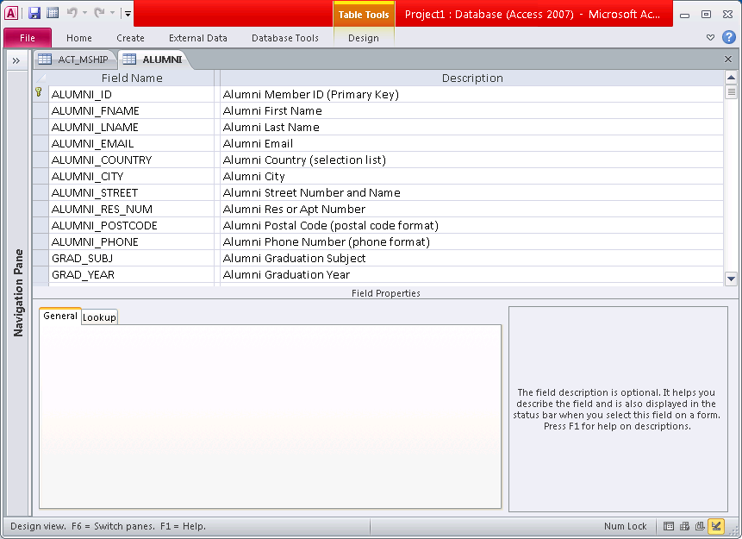

|  |  |  |  |  |  |
| --- | --- | --- | --- | --- | --- |
| ALUMNI_ID | ALUMNI_FNAME | ALUMNI_LNAME | ALUMNI_EMAIL | ALUMNI_COUNTRY | ALUMNI_CITY |
| A10000 | Mike | Brown | mbrown213@gmail.com | Canada | Vancouver |
| A10001 | Lebron | James | ljames23@gmail.com | Canada | Burnaby |
| A10002 | David | Beckham | dbeckham23@gmail.com | Canada | Vancouver |
| A10003 | Venus | Williams | vwilliams111@gmail.com | Canada | Vancouver |
| A10004 | Katy | Perry | kperry8787@gmail.com | Canada | Vancouver |
| A10006 | John | Smith | jsmith777888@gmail.com | Canada | Vancouver |

|  |  |  |  |  |  |
| --- | --- | --- | --- | --- | --- |
| ALUMNI_STREET | ALUMNI_RES_NUM | ALUMNI_POSTCODE | ALUMNI_PHONE | GRAD_SUBJ | GRAD_YEAR |
| 820 Happy Ave. | 11 | V1K 1K1 | (604) 888-8881 | english | 1990 |
| 100 Google St. |  | V4K 1A2 | (604) 123-1333 | sports | 2000 |
| 7888 England St. | 55 | V8K 1Z2 | (604) 232-3232 | sports | 2003 |
| 2111 Wilson St. |  | V1A 1S4 | (604) 388-1311 | arts | 2006 |
| 7677 Poppy St. | 33 | V1D 1P3 | (604) 111-8222 | music | 2008 |
| 54521 Richard Ave. |  | V3B 1P2 | (604) 311-8888 | physics | 2010 |

### ACT_MSHIP ENTITY

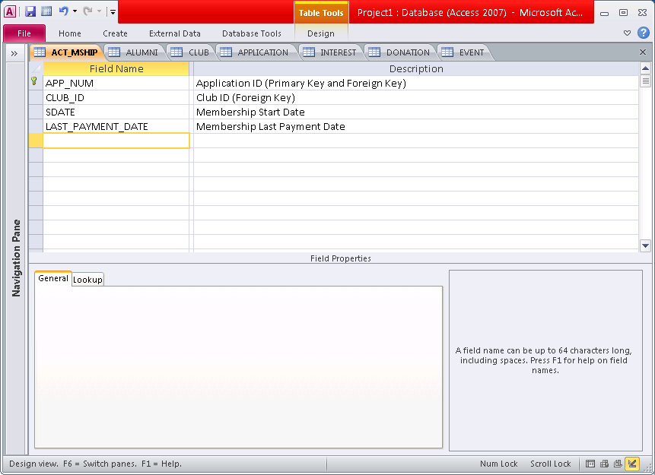

|  |  |  |  |
| --- | --- | --- | --- |
| APP_NUM | CLUB_ID | SDATE | LAST_PAYMENT_DATE |
| 3 | C100 | 06/01/2003 | 06/01/2014 |
| 4 | C100 | 06/01/2006 | 06/01/2014 |
| 5 | C100 | 06/01/2008 | 06/01/2014 |
| 6 | C100 | 06/01/2010 | 06/01/2014 |
| 7 | C105 | 01/01/2011 | 01/01/2014 |

### APPLICATION ENTITY

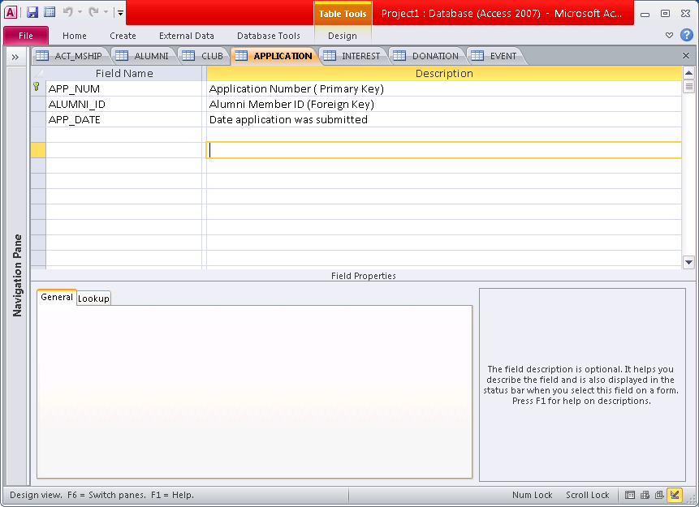

|  |  |  |
| --- | --- | --- |
| APP_NUM | ALUMNI_ID | APP_DATE |
| 1 | A10000 | 04/01/1990 |
| 2 | A10001 | 05/01/2000 |
| 3 | A10002 | 05/15/2003 |
| 4 | A10003 | 05/02/2006 |
| 5 | A10004 | 05/15/2008 |
| 6 | A10005 | 05/01/2010 |
| 7 | A10005 | 12/20/2010 |

### CLUB ENTITY

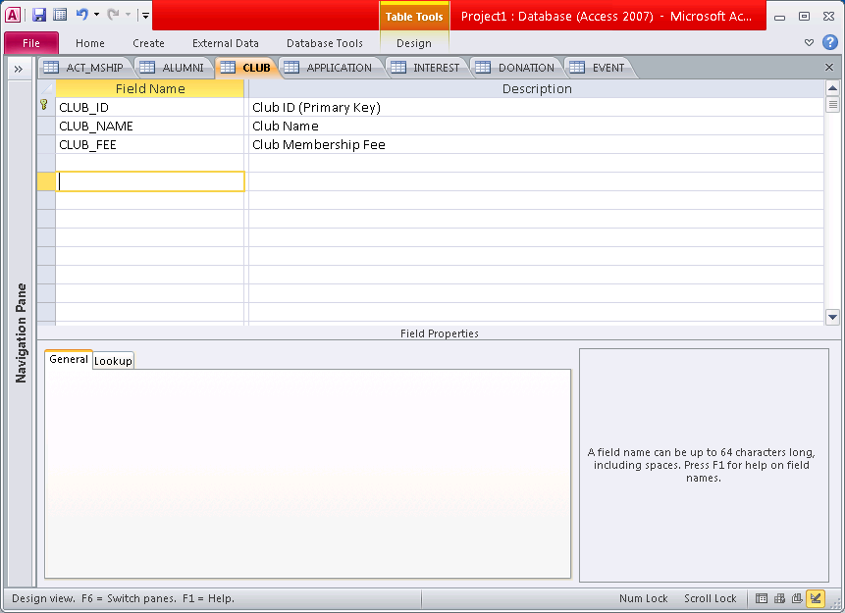

|  |  |  |
| --- | --- | --- |
| CLUB_ID | CLUB_NAME | CLUB_FEE |
| C100 | Special | $0.00 |
| C101 | Astronomy | $30.00 |
| C102 | Badminton | $50.00 |
| C103 | Tennis | $50.00 |
| C104 | Computer | $40.00 |
| C105 | Chess | $50.00 |
| C106 | Rowing | $30.00 |

### DONATION ENTITY

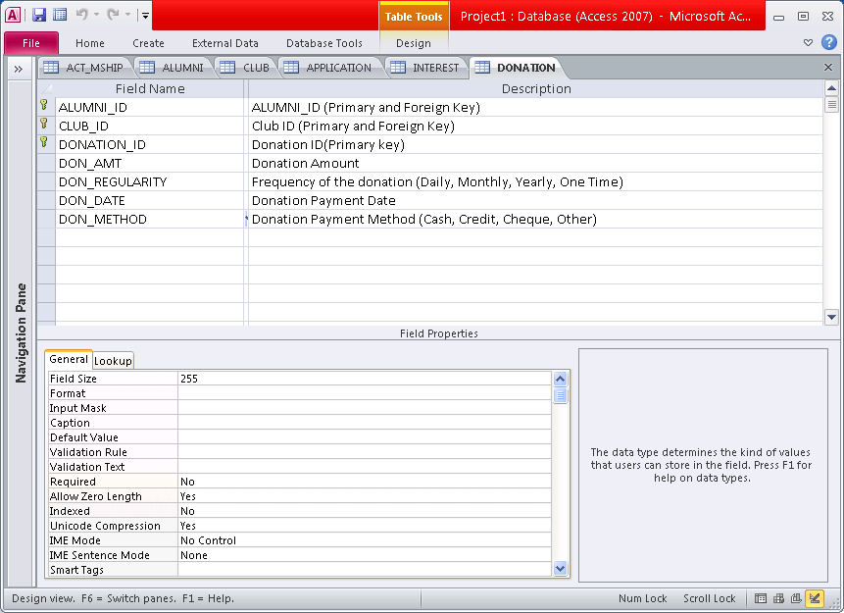

|  |  |  |  |  |  |  |
| --- | --- | --- | --- | --- | --- | --- |
| ALUMNI_ID | CLUB_ID | DONATION_ID | DON_AMT | DON_REGULARITY | DON_DATE | DON_METHOD |
| A10001 | C103 | 5 | $200.00 | Monthly | 20-Oct-12 | Cheque |
| A10006 | C100 | 1 | $400.00 | One Time | 01-Aug-12 | Credit Card |
| A10006 | C101 | 2 | $150.00 | One Time | 14-Feb-11 | Credit Card |
| A10006 | C105 | 3 | $250.00 | One Time | 01-Nov-12 | Credit Card |
| A10006 | C106 | 4 | $100.00 | Yearly | 20-Oct-12 | Credit Card |

### EVENT ENTITY

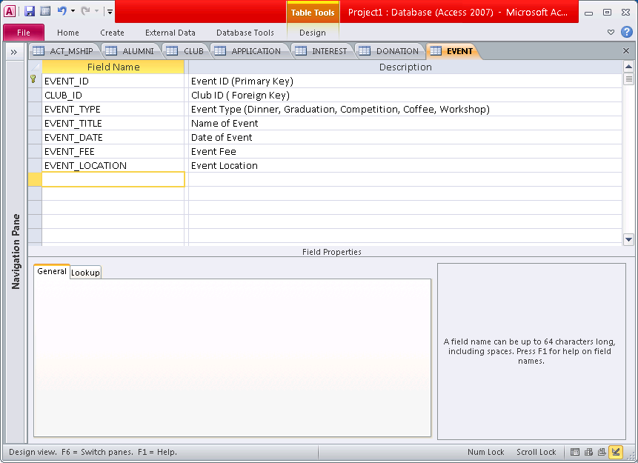

|  |  |  |  |  |  |  |
| --- | --- | --- | --- | --- | --- | --- |
| EVENT_ID | CLUB_ID | EVENT_TYPE | EVENT_TITLE | EVENT_DATE | EVENT_FEE | EVENT_LOCATION |
| CH1001 | C105 | Competition | Chess Competition Vancouver 2009 | 05/02/2010 | $30.00 | Trout Lake Community Center - Room 205 |
| CO1001 | C104 | Convention | Computer Club Convention 2008 | 10/20/2008 | $40.00 | Vancouver Convention  Center - Room 105 |
| CO1002 | C104 | Workshop | Computer Club Workshop Oct 2008 | 10/29/2008 | $20.00 | BCIT - Building SE6 Room 104 |
| SP1010 | C100 | Dinner | Alumni Special Dinner May 2000 | 05/02/2000 | $40.00 | The Keg Steakhouse -  Yaletown |
| SP1050 | C100 | Graduation | Alumni Graduation 2001 | 06/15/2001 | $0.00 | The Chan Center |

### FMR_MSHIP ENTITY

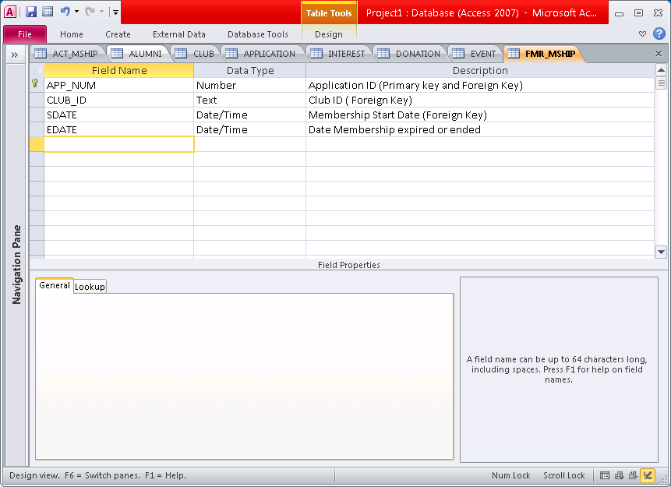

|  |  |  |  |
| --- | --- | --- | --- |
| APP_NUM | CLUB_ID | SDATE | EDATE |
| 1 | C100 | 06/01/1990 | 06/01/1995 |
| 2 | C100 | 06/01/2000 | 06/01/2005 |

### INTEREST ENTITY

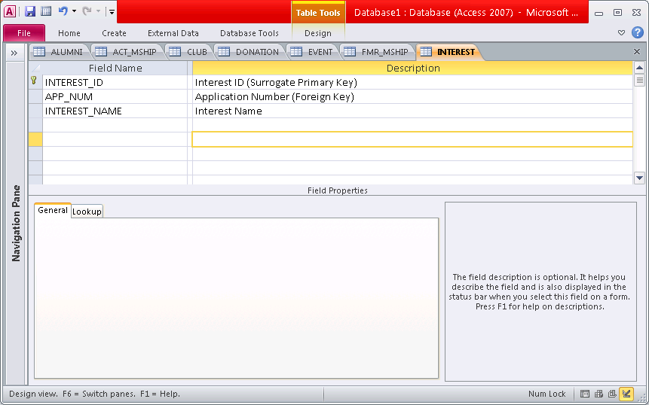

|  |  |  |
| --- | --- | --- |
| INTEREST_ID | APP_NUM | INTEREST_NAME |
| 1 | 1 | basketball |
| 2 | 1 | tennis |
| 3 | 1 | cooking |
| 4 | 1 | chess |
| 5 | 2 | tennis |
| 6 | 2 | basketball |
| 7 | 6 | chess |
| 8 | 6 | computers |
| 9 | 7 | chess |

### INVITATION ENTITY

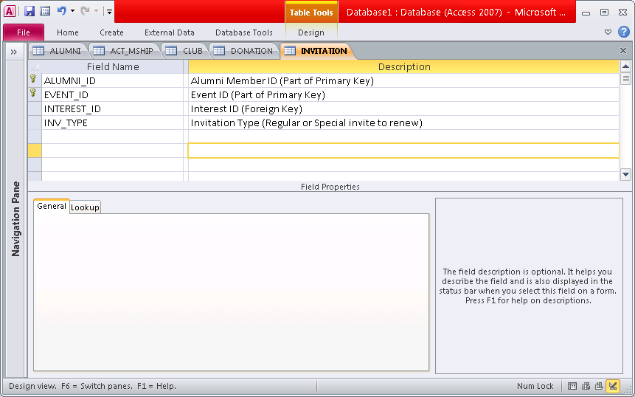

|  |  |  |  |
| --- | --- | --- | --- |
| ALUMNI_ID | EVENT_ID | INTEREST_ID | INV_TYPE |
| A10000 | SP1001 |  | Special |
| A10001 | CH1001 |  | Special |
| A10003 | SP1001 | 5 | Regular |
| A10005 | CH1001 | 7 | Regular |
| A10005 | CO1001 | 8 | Regular |

# Sample Reports

### Report 1: Membership Tracker

This report shows all the memberships (Alumni and/or clubs) for a member. It shows the membership name (club association or alumni), status (Active, Holding, Former) as well as when the membership started, last payment date, and the end date (which is derived one year after the last payment date).Lastly, it shows how much was paid towards each membership. For the Alumni membership, the feels free the first year. The report is sorted by Membership Name.

The report is derived from the following entities: ALUMNI, ACT_MSHIP, FMR_MSHIP, APPLICATION and CLUB.

|  |  |  |  |  |  |  |
| --- | --- | --- | --- | --- | --- | --- |
| MEMBERSHIP TRACKER | | | | | | |
|  |  |  |  |  | **Report Date: 06/10/2014** | |
|  |  |  |  |  |  |  |
| ***MEMBER DETAILS:*** | |  |  |  |  |  |
|  |  |  |  |  |  |  |
| ID: | **A10005** |  |  | NAME: | **John Smith** | |
| PHONE: | **604-777-8888** |  |  | E-MAIL: | **jsmith77788@gmail.com** | |
|  |  |  |  |  |  |  |
|  |  |  |  |  |  |  |
| ***MEMBERSHIP DETAILS:*** | |  |  |  |  |  |
|  |  |  |  |  |  |  |
| **Membership Name** | **Start Date** | **Last Payment Date** | **End** | **Membership Status** | **Fee** | **Total** |
| **Date** | **Fee Paid** |
|  |  |  |  |  |  |  |
| Alumni | 06/01/2010 | 06/01/2014 | 06/01/2015 | Active | $35.00 | **$105.00** |
| Astronomy | 01/01/2013 | 01/01/2013 | 01/01/2014 | Holding | $20.00 | **$20.00** |
| Chess | 01/01/2011 | 09/01/2013 | 09/01/2014 | Active | $20.00 | **$60.00** |
| Computer | 01/01/2011 | 01/01/2012 | 01/01/2013 | Former | $15.00 | **$30.00** |
| Rowing | 01/01/2014 | 01/01/2014 | 01/01/2015 | Active | $30.00 | **$30.00** |
|  |  |  |  |  |  |  |

### Report 2: Member's Events

This report shows a member’s upcoming and past events. The upcoming events group is determined by the event date and if it’s dated in the future and is sorted in ascending order. The past events group is determined by the event date and if it’s dated in the past and is sorted in descending order.

The report is derived from the following entities: ALUMNI, ACT_MSHIP, FRM_MSHIP, APPLICATION, INVITATION, EVENT and CLUB.

|  |  |  |  |  |  |  |
| --- | --- | --- | --- | --- | --- | --- |
| ALUMNI'S EVENTS | | | | | | |
|  |  |  |  |  | **Report Date: 06/10/2014** | |
| ***MEMBER DETAILS:*** | |  |  |  |  |  |
|  |  |  |  |  |  |  |
| ALUMNI ID: | **A10005** |  |  | NAME: | **John Smith** | |
| PHONE: | **604-777-8888** |  |  | E-MAIL: | **jsmith777888@gmail.com** | |
|  |  |  |  |  |  |  |
| ***EVENTS DETAILS:*** | |  |  |  |  |  |
|  |  |  |  |  |  |  |
| **UPCOMING EVENTS** | | | | | | |
|  |  |  |  |  |  |  |
| **Event ID** | **Membership Name** | **Event  Type** | **Event Date** | **Membership Status** | **Location** | **Event Fee** |
|
|  |  |  |  |  |  |  |
| CH1150 | Chess | Competition | 07/15/2014 | Active | Trout Lake Community Center - Room 205 | $20.00 |
| RO1010 | Rowing | Dinner | 08/20/2014 | Active | Cactus Club -  Broadway and Granville | $40.00 |
| AS1020 | Astronomy | Coffee | 09/01/2014 | Holding | Starbucks -  Robson and Thurlow | $10.00 |
| SP1500 | Alumni | Dinner | 09/15/2014 | Active | The Keg Steakhouse -  Yaletown | $50.00 |
|  |  |  |  |  |  |  |
| **PAST EVENTS** | | | | | | |
|  |  |  |  |  |  |  |
| **Event ID** | **Membership Name** | **Event  Type** | **Event Date** | **Membership Status** | **Location** | **Event Fee** |
|
|  |  |  |  |  |  |  |
| CH1070 | Chess | Competition | 07/01/2013 | Active | Trout Lake Community Center - Room 205 | $20.00 |
| CO1007 | Computer | Convention | 05/15/2012 | Former | Vancouver Convention  Center - Room 105 | $50.00 |
| SP1001 | Alumni | Graduation | 06/15/2010 | Active | The Chan Center | $0.00 |
|  |  |  |  |  |  |  |

### Report 3: Club Member's Information

This Report shows the Active and Holding members within a club association. The report is sorted by Last Name for each status group (Active/Holding).

The report is derived from the following entities: **ALUMNI, ACT_MSHIP, APPLICATION** and **CLUB**.

|  |  |  |  |  |  |
| --- | --- | --- | --- | --- | --- |
| CLUB MEMBERS INFORMATION | | | | | |
|  |  |  |  | **Report Date: 06/10/2014** | |
|  |  |  |  |  |  |
| CLUB ID: | **C110** |  |  |  | |
| CLUB NAME: | **Chess** |  |  |  | |
| MEMBERSHIP FEE: | **$50.00** |  |  |  |  |
|  |  |  |  |  |  |
| ***MEMBERS LIST:*** | |  |  |  |  |
|  |  |  |  |  |  |
| **ACTIVE** | | | | | |
| **Alumni ID** | **First Name** | **Last Name** | **Start Date** | **Last Payment Date** | **End Date** |
|
|  |  |  |  |  |  |
| A10220 | Alex | Burrows | 05/01/2005 | 05/01/2014 | 05/01/2015 |
| A10260 | Peter | Chow | 06/15/2007 | 09/21/2013 | 09/21/2014 |
| A10020 | Romeo | Montague | 02/01/2010 | 02/01/2014 | 02/01/2015 |
| A10005 | John | Smith | 01/01/2011 | 09/01/2013 | 09/01/2014 |
|  |  |  |  |  |  |
|  |  |  |  |  |  |
| **HOLDING** | | | | | |
| **Alumni ID** | **First Name** | **Last Name** | **Start Date** | **Last Payment Date** | **End Date** |
|
|  |  |  |  |  |  |
| A10017 | Jane | Doe | 01/20/2010 | 01/20/2013 | 01/20/2014 |
| A11200 | Roberto | Loungo | 03/01/2012 | 03/01/2013 | 03/01/2014 |
| A11677 | Cory | Schneider | 04/10/2011 | 11/10/2013 | 04/10/2014 |
|  |  |  |  |  |  |

### Report 4: Alumni's Donations

This report shows the percentage breakdown of an Alumni’s total donations. The General category specifies a “special” club association in the club entity.

The report is derived from the following entities: ALUMNI, DONATION and CLUB.

# Process Descriptions

Having started from only a few simple business rules, we've been able to expand our descriptions of various entities and relationships in order to specify the needs of our database implementation. Reaching this result was only possible after a chronological breakdown of the necessary processes it would take for us to complete this task. Here's how we went about it:

Upon looking at the initial rules and descriptions we were given, we started by penning down a list of the minimum required entities as we saw fit. We started with five:

ALUMNI, CLUB, EVENT, MEMBERSHIP, INVITATION

From here we decided that it's impossible for us to go any further without attempting to describe all the necessary attributes within this database (even given such a limited number of entities). So we tried our best to come up with as many useful attributes as we could and wrote them all down under our Alumni entity in a basic relational schema. From there we normalized to 3NF (See page 5) and ended up with two new entities. Our list of entities was as follows:

ALUMNI, CLUB, EVENT, MEMBERSHIP, INVITATION, DONATION, INTEREST

When drawing a draft ERD we took notice at the fact that certain entities were already bridge entities that resolved M:N relationships. From there we came up with more business rules to further explain these relationships. Some of the business rules we came up with didn't make the final cut as we saw them as being redundant or describing relationships between an entity and a bridge entity.

We decided to simply and looked closer at our ERD. It became obvious that implementing a membership entity wasn't going to be enough for the requirements of this database. Having come to this realization, we amended our ERD with the necessary entities are redrew our Normalized Relational Schema to accommodate these changes. The final versions of our respective duties were set in stone at this point.

From this point, all that was left was to create sample data and sample reports, as well as coming up with a list of our various assumptions and limitations that we had to make in order to implement our database properly. The final result is before you now.

# Assumptions/LImitations

Asking questions is an important part of any database design process. While we've had the opportunity as a team to ask many questions and bounce ideas off of each other, there remain some questions we failed to ask on time. This created a gap in our knowledge pertaining to important design choices in our database implementation.

It is at this point that certain assumptions have to be made in order to ensure that our database has structural integrity. The following are the assumptions we've had to make under which our database operates.

* Each alumni must have an active membership.
* An invitation does not need to be present in any situation.
* An invitation can only be based off of one interest.
* There is a processing time delay between the application date and the membership start date .
* The CLUB_ID can have a special value that defines a non-specific, or general, club.
* A club can exist without any alumni because none have signed up for it upon its formation.
* An event can only be hosted by one club.

With these assumptions come certain limitations in our database itself. Here are some examples of limitations that our database encounters:

* An invitation cannot be based on more than one interest.
* An ad hoc query trying to find Graduation Year and Subject information to send Invitations through might be complicated.
* It is possible that an application may not result in an active membership which can theoretically result in an empty ACT_MSHIP table.
* A middle ground between ALUMNI and ACT_MSHIP is necessary to reconcile the fact that an Alumni must belong to a club but that there may be no clubs for Alumni to join. We've decided to call it an application.
* This creates a further barrier between an Alumni and their professed interests.

# Conclusions - Observations

The rift between theory and practice cannot be traversed without getting your hands dirty. This doesn't become more obvious than when trying to implement an External Model from scratch. There were many internal conflicts that we faced trying to come up with an optimal design for this problem. While many of our disagreements were ultimately resolved, it was apparent that they all stemmed from a lack of knowledge or sufficient information.

If we were to have a second stab at this, I think the first thing that we would all do would be to try and come up with an ERD as soon as possible and then try to implement our entities through sample data to see if everything is consistent and makes sense. The late questions that we came up with after having realized that our design implementation featured many inconsistencies were by far the most difficult to resolve and forced us to resort to our own critical faculties in trying to figure out a clear-cut logical solution with the cleanest and safest assumptions in order to un-break the design.

Another thing we observed while working on this problem was the tremendous ripple effect that takes place when trying to modify or change a single attribute from one table to the next. Some of them were so extreme and so far down the line that they forced us to rethink our entire model more than once. For instance, trying to find a way to reconcile the ALUMNI-ACT_MSHIP relationship was very challenging. On the one hand we knew that every Alumni needed to be part of a club, but on the other it was obvious that the ACT_MSHIP table could very well be empty, and the same was the case for the FMR_MSHIP table which we initially related directly to both ALUMNI and CLUB. The solution we ultimately agreed upon was the introduction of an APPLICATION entity which bridged this divide and further allowed us to implement INTEREST in a creative way that we previously hadn't thought of.

I think the entire problem requires a great deal of visual thinking and the processes we undertook to resolve it were unavoidably visual. For instance, imagining the APPLICATION process (and ultimately, entity) as a form was a crucial step in arriving to our final design. Similarly, envisioning the tables that all these entities would produce was also important in identifying any inconsistencies, especially pertaining to the integrity of our primary keys in their ability to uniquely identify entity occurrences.

An example of this came about when relating the INTEREST and INVITATION entities. It became obvious that trying to implement more than one INTEREST in an INVITATION could become a problem due to repeating groups that would emerge as a result of Alumni sharing interests. Even looking at it now it beckons us to find a more optimal design, or in general a better way to implement this relationship. However as mentioned before, a lack of information and the failure to ask the right questions at the right time forced our hands in a way and ultimately resulted in this final design which, while satisfying to a certain extent, is always subject to improvements (like any database is).

In conclusion, this project was a good exercise in getting us to walk through the design process and getting a real feel for the actual challenges and nuances of implementing a database and working as part of a DB team to try and achieve the same goal.